**THINK-CHAMP PRIVATE LIMITED**

INTERNSHIP REPORT on

**PYTHON PROJECT -4: Using python Password Checking**



SUBMITTED TO:

CEO OF THINK CHAMP PVT LTD

**GURU LOKESH SIR**

**SUBMITTED BY:**

**K.Lavanya**

INDEX

S.NO CONTENTS

1. Project-4------------------------------------------

1.1 Introduction ------------------------------------

1.2 Steps --------------------------------------------

1.3 Software requirements specification ----

1.4 Coding -------------------------------------------

1.5 Output ------------------------------------------

1.6 Conclusion --------------------------------------

**Project-4:**

* 1. **Introdu** **ction**

A Password is a used to prove one’s identity, or  
authorize access to a resource. The importance of  
strong password is creating a strong and secure  
password can reduce the risk of cybercriminals  
guessing your password and accessing sensitive  
data. The password characteristic of strong  
password at least 8 characters the longer the better.  
 A mixture of both uppercase and lowercase letters.A mixture of letters and numbers. Inclusion of atleast one special character.

**1.2 . Steps**

* First we have to open the idle  
  And then import the string and get pass  
  separately.
* Now, we have to create a function.
* we have to give password ,remarks and other variables .
* Now, we have to for loop for the some  
  conditions.
* After that we have give the if conditions to  
  check the whether it is a strong password or not.
* Again we have to give the conditions for to  
  check the strong password and print the  
  statements whether it is strong or not.
* Again we have to declare the another function.
* After that we have some conditions to check the password strong or not.
* That end the program.

**1.3 Software requirements specification**

S0FTWARE REQUIREMENTS:

• Operating System: Windows 11

• Coding Language: PYTHON

• Software: PyCharm

HARDWARE REQUIREMENTS:

• System: PAVILION

• Hard Disk: 512 GB

• Ram: 8 GB

**1.4 Coding**

import string

import getpass

def check_password_strength():

password = getpass.getpass('Enter the password: ')

strength = 0

remarks = ''

lower_count = upper_count = num_count = wspace_count = special_count = 0

for char in list(password):

if char in string.ascii_lowercase:

lower_count += 1

elif char in string.ascii_uppercase:

upper_count += 1

elif char in string.digits:

num_count += 1

elif char == ' ':

wspace_count += 1

else:

special_count += 1

if lower_count >= 1:

strength += 1

if upper_count >= 1:

strength += 1 7

if num_count >= 1:

strength += 1

if wspace_count >= 1:

strength += 1

if special_count >= 1:

strength += 1

if strength == 1:

remarks = ('That\'s a very bad password.'

' Change it as soon as possible.')

elif strength == 2:

remarks = ('That\'s a weak password.'

' You should consider using a tougher password.')

elif strength == 3:

remarks = 'Your password is okay, but it can be improved.'

elif strength == 4:

remarks = ('Your password is hard to guess.'

' But you could make it even more secure.')

elif strength == 5:

remarks = ('Now that\'s one hell of a strong password!!!'

' Hackers don\'t have a chance guessing that password!')

print('Your password has:-')

print(f'{lower_count} lowercase letters')

print(f'{upper_count} uppercase letters')

print(f'{num_count} digits')

print(f'{wspace_count} whitespaces')

print(f'{special_count} special characters')

print(f'Password Score: {strength / 5}')

print(f'Remarks: {remarks}') 8

def check_pwd(another_pw=False):

valid = False

if another_pw:

choice = input(

'Do you want to check another password\'s strength (y/n) : ')

else:

choice = input(

'Do you want to check your password\'s strength (y/n) : ')

while not valid:

if choice.lower() == 'y':

return True

elif choice.lower() == 'n':

print('Exiting...')

return False

else:

print('Invalid input...please try again. \n')

if __name__ == '__main__':

print('===== Welcome to Password Strength Checker =====')

check_pw = check_pwd()

while check_pw:

check_password_strength()

check_pw = check_pwd(True)

**OUTPUT:**

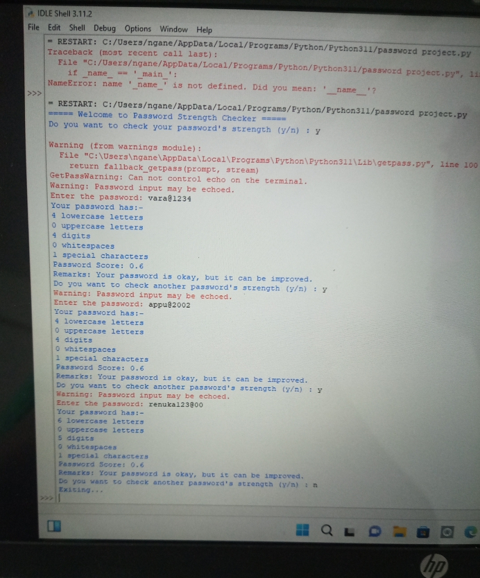

**1.6 Conclusion**

Here we can check the password strong or not. It can use a lot for the whether strong or not. With the help of this we make can our password strong.